### Report

### On

### Creating an EC2 instance of given Vmdk file

### Problem Statement: How to create a new Amazon EC2 instance from VMDK, .Ovf, .mf file.

**Procedures:** These are the ways through which we can try to overcome this problem.

1. **We can import existing vmdk file to our Amazon EC2.**

Steps used in this process

1. **We should have a .vmdk file of a VM.**
2. **Install ec2-api-tools**

#wget http://launchpadlibrarian.net/111617788/ec2-api-tools_1.6.1.1-0ubuntu1_all.deb

#sudo dpkg -i ec2-api-tools_1.6.1.1-0ubuntu1_all.deb

1. **Check the Version of ec2-api-tools**

#ec2-version

1. **Export Aws access key, secret key and user id.**

#export AWS_ACCESS_KEY=XXXXXXXXXXXXXXXX  
 #export AWS_SECRET_KEY=XXXXXXXXXXXXXXXX

1. **Create EC2 Instance using *.vmdk**#ec2-import-instance openBsd.vmdk -f VMDK -t m1.small -a x86_64 -b import-export- o $AWS_ACCESS_KEY -w $AWS_SECRET_KEY --region us-west-1
2. **Check the Progress of the task**

#ec2-describe-conversion-tasks import-i-ffm2nty0 -O $AWS_ACCESS_KEY -W $AWS_SECRET_KEY --region us-west-1

(Where Task Id is ffm2nty0)

1. **Resume task**

#ec2-resume-import openBsd.vmdk -t import-i-ffm2nty0 -o $AWS_ACCESS_KEY -w $AWS_SECRET_KEY --region us-west-1

(The Disk image for task id Import –i-ffm2nty0 has been uploaded to Amazon S3 where it is being converted into EC2 instance).

1. **Remove the image from S3, when the task completed**

#ec2-delete-disk-image -t import-i-ffm2nty0 -o $AWS_ACCESS_KEY -w $AWS_SECRET_KEY --region us-west-1

**Problem faced with this approach:** This was the error that I received while creating an instance of an OPENBSD vmdk file to AWS using EC2 API tools.

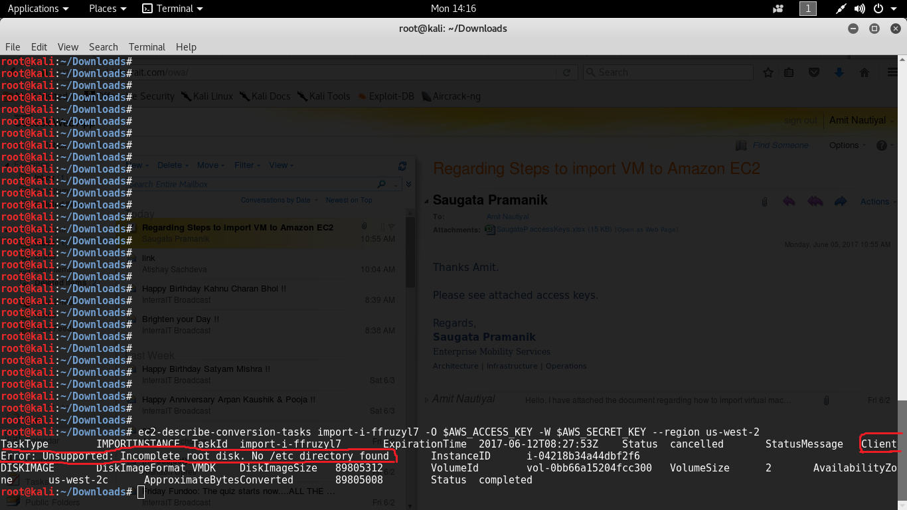

I tried using Ubuntu, Kali Linux but the same error persisted.  
AWS does not support creation of OpenBSD instance using Windows platform.  
First of all, I presumed that this error is due to a corrupt vmdk, so I re-downloaded it but it didn't help.  
There is not much information on the Internet about how to create an instance of OpenBSD on AWS.  
So I started looking at the error which is a Client Error**. The AWS documentation says this:**Client errors are usually caused by something the client did, such as specifying an incorrect or invalid parameter in the request, or using an action or resource on behalf of a user that doesn't have permission to use the action or resource. These errors are accompanied by a 400-series HTTP response code.

1. **Another approach we can try to migrate an OpenBSD VM to AWS**
2. **We should have a disk for AWS.**
3. **Convert vmdk file to VHD (virtual Hard Disk) file using Virtual Box.**
4. **Install ec2-api-tools**

#wget http://launchpadlibrarian.net/111617788/ec2-api-tools_1.6.1.1-0ubuntu1_all.deb

#sudo dpkg -i ec2-api-tools_1.6.1.1-0ubuntu1_all.deb

1. **Export Aws access key, secret key.**

#exportAWS_ACCESS_KEY=XXXXXXXXXXXXXXXX  
 #export AWS_SECRET_KEY=XXXXXXXXXXXXXXXX

1. **Import Volume In AWS**

#ec2-import-volume openBsd.vhd -f VHD –s 8 --region us-west-2 –z us-west-2a -b openBSD-keytalk- o $AWS_ACCESS_KEY -w $AWS_SECRET_KEY –O $AWS_ACCESS_KEY –W $AWS_SECRET_KEY

**NOTE:**

Once the volume is imported (we can check with ec2-describe-conversion-tasks), it should show up as a volume in the AWS Portal (Services -> EC2 -> Volumes).

 Spin up a Linux instance. Stop it. Detach the root volume. Attach the shiny new OpenBSD volume as "/dev/xvda" to our sacrificial Linux instance. Start the instance.

As long as we are **NOT** using enhanced networking (there appears to be an as-of-yet-unresolved issue with the OpenBSD 82599 driver attaching to Xen-emulated Intel cards?), we should see 2/2 health checks after a short while.